**Overcoming the Wear in Agriculture Industry**

Wear is a common challenge faced by the agriculture industry, primarily stemming from the contact between equipment and the ground. This reality underscores the importance of making well-informed choices when it comes to selecting wear-resistant parts, considering local conditions and usage patterns. In the agriculture industry, leveraging the benefits of abrasion resistant steel in various applications not only addresses wear-related challenges but also contributes to improved performance, extended equipment life, and overall operational efficiency.

**A. Combine Harvesters: Efficient Grain Harvesting Made Possible**

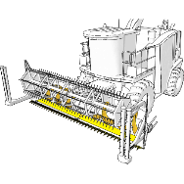

Combine harvesters are versatile machines that efficiently handle a wide range of grain crops. They perform the tasks of reaping, threshing, and winnowing in a single operation. In this context, the use of abrasion resistant steel is pivotal in creating wear-resistant components for harvester blades and header augers. This choice ensures the durability required for sustained performance.

Benefits of using abrasion-resistant steel in combine harvester blades and header augers:

1. **Extended service life**: Abrasion-resistant steel can extend the service life of the blades and header augers by several years. This is because the steel is less likely to wear away than regular steel, so it can last longer and harvest more crops.
2. **Reduced maintenance:** Abrasion-resistant steel can reduce the need for maintenance. This is because the steel is less likely to corrode or rust, and it is also more resistant to dents and scratches.
3. **Improved efficiency:** Abrasion-resistant steel can improve the efficiency of the combine harvester. This is because the steel is less likely to deform or bend, which means that the harvester can operate at a higher speed without the risk of damage.
4. **Reduced downtime:** When a combine harvester is not in use, the blades and header augers can be stored in a protective environment. This will help to prevent the steel from being exposed to the elements, which can extend its lifespan even further.

**Grades:** AR400 or AR500 steel can be used for Combine Harvesters. These steel grades are strong enough to withstand the wear and tear of harvesting crops, and they are also ductile enough to bend without breaking.

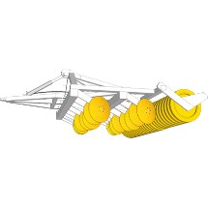**B. Harrows: Preparing Soil for Optimal Crop Growth**

Harrows play a crucial role in soil preparation before planting or for weed control. There are various types such as disc harrows, tine harrows, and chain harrows. Among these, disc harrows, often crafted from boron steel, benefit significantly from the incorporation of abrasion resistant steel. This results in improved service life and quicker delivery, bypassing the need for time-consuming heat treatment.

Benefits of using abrasion-resistant steel in disc harrows:

1. **Extended service life:** Abrasion-resistant steel can extend the service life of the discs by several years. This is because the steel is less likely to wear away than regular steel, so it can last longer and prepare more soil.
2. **Improved performance**: Abrasion-resistant steel can improve the performance of the disc harrow. This is because the steel is less likely to deform or bend, which means that the harrow can operate at a higher speed without the risk of damage.
3. **Quicker delivery**: Abrasion-resistant steel does not require heat treatment, which can speed up the delivery of the harrow.

**Grades:** AR400 or AR450 steel can be used for harrows. These steel grades are a good balance of strength and abrasion resistance, making them ideal for most applications.

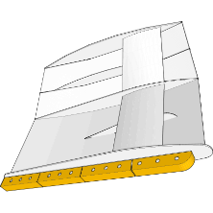**C. Trawl Doors: Enhancing Durability for Efficient Bottom Trawling**

Trawl doors are subject to heavy sliding wear during bottom trawling operations. Here, the use of abrasion resistant steel presents a solution that not only enhances durability but also reduces weight. This, in turn, leads to more fuel-efficient operations and a more sustainable approach.

Benefits of using abrasion-resistant steel in trawl doors:

1. **Enhanced durability:** Abrasion-resistant steel can extend the service life of trawl doors by several years. This is because the steel is less likely to wear away than regular steel, so it can last longer and catch more fish.
2. **Reduced weight:** Abrasion-resistant steel is lighter than regular steel, which can help to reduce the fuel consumption of the trawler. This is a more sustainable approach.
3. **Improved performance:** Abrasion-resistant steel can improve the performance of the trawl doors. This is because the steel is less likely to deform or bend, which means that the doors can operate at a higher speed without the risk of damage.

**Grades:** AR450 or AR500 steel can be used for trawl doors. These steel grades are strong enough to withstand the wear and tear of bottom trawling, and they are also resistant to impact damage.

**D. Grain Silos: Preserving Grains Through Effective Wear Resistance**

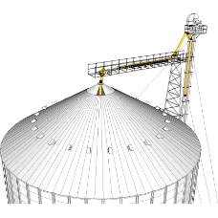

Grain silos serve as storage units for grains and silage, with wear being a common concern in the outlet chutes. The presence of abrasive particles accompanying the stored grains leads to wear. The application of abrasion resistant steel in silo chutes has proven to effectively counter this wear, contributing to prolonged equipment life.

Benefits of using abrasion-resistant steel in grain silo chutes:

1. **Extended service life:** Abrasion-resistant steel can extend the service life of the chutes by several years. This is because the steel is less likely to wear away than regular steel, so it can last longer and store more grains.
2. **Reduced maintenance:** Abrasion-resistant steel is less likely to corrode or rust, which means that it requires less maintenance.
3. **Improved efficiency:** Abrasion-resistant steel can improve the efficiency of the silo. This is because the steel is less likely to deform or bend, which means that the chutes can operate at a higher speed without the risk of damage.
4. **Reduced downtime:** When a grain silo is not in use, the chutes can be stored in a protective environment. This will help to prevent the steel from being exposed to the elements, which can extend its lifespan even further.

**Grades:** AR400 or AR450 steel can be used for grain silos. These steel grades are strong enough to withstand the wear and tear of grain storage, and they are also resistant to corrosion.

**E. Plows: Enhancing Plows Performance and Longevity**

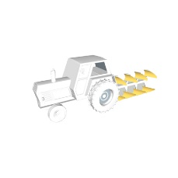

Plows, which penetrate the soil to prepare it for cultivation, encounter significant wear, especially when encountering rocks. Incorporating abrasion resistant steel into Plows components, particularly Plows cutting edges, extends the service life of these crucial agricultural tools. This choice enhances efficiency and reduces maintenance needs.

Benefits of using abrasion-resistant steel in Plows components:

1. **Extended service life:** Abrasion-resistant steel can extend the service life of the Plows components by several years. This is because the steel is less likely to wear away than regular steel, so it can last longer and Plow more soil.
2. **Reduced maintenance**: Abrasion-resistant steel is less likely to corrode or rust, which means that it requires less maintenance.
3. **Improved efficiency:** Abrasion-resistant steel can improve the efficiency of the Plows. This is because the steel is less likely to deform or bend, which means that the Plows can operate at a higher speed without the risk of damage.
4. **Reduced downtime:** When a Plows is not in use, the components can be stored in a protective environment. This will help to prevent the steel from being exposed to the elements, which can extend its lifespan even further.

**Grades:** AR450 or AR500 steel can be used for Plows. These steel grades are strong enough to withstand the wear and tear of Ploughing, and they are also resistant to impact damage.